**CS-405 2-3 Activity: Buffer Overflow Coding**

**Jason Farrell**

**Southern New Hampshire University**

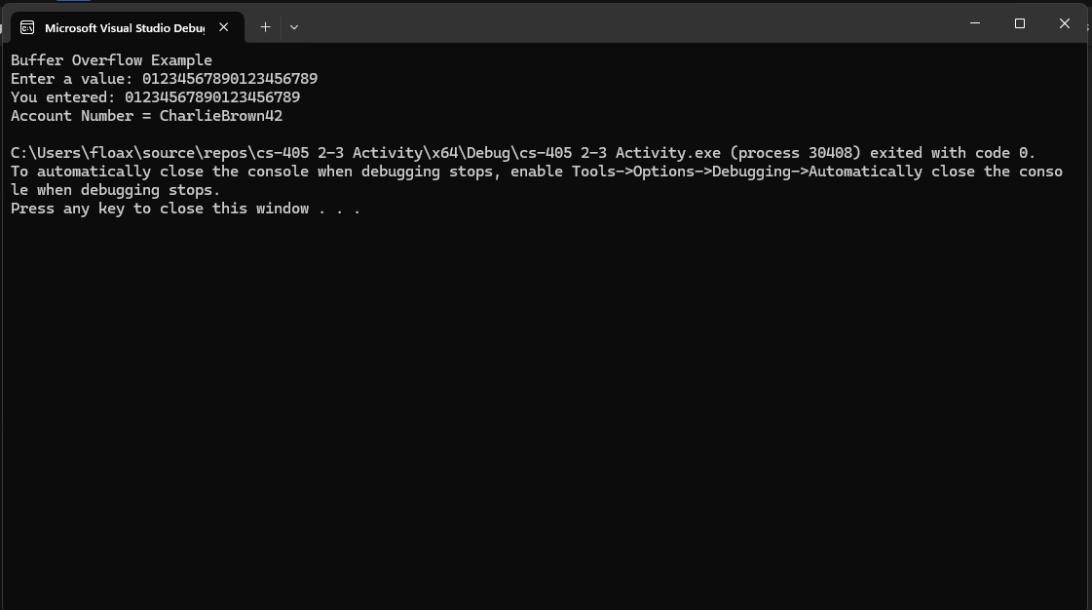

For this assignment, since it was using C style null terminated strings with C++ streams, I added one byte in the declaration for the user_input so that it could hold exactly 20 with the one-byte null value. I then used cin.width method to contain input to exactly 20 plus the one-byte null value. This enabled the application to accept exactly 20 + the null terminated value and no longer interferes with the account_number variable. What is interesting with my Win11 system is that I caught an exception when the program was not modified when I entered more than 20 bytes. The exception was caught right after and thus never truly showed me that it overwrote the account_number.